# CS 255 System Design Document Template

## UML Diagrams

### UML Use Case Diagram

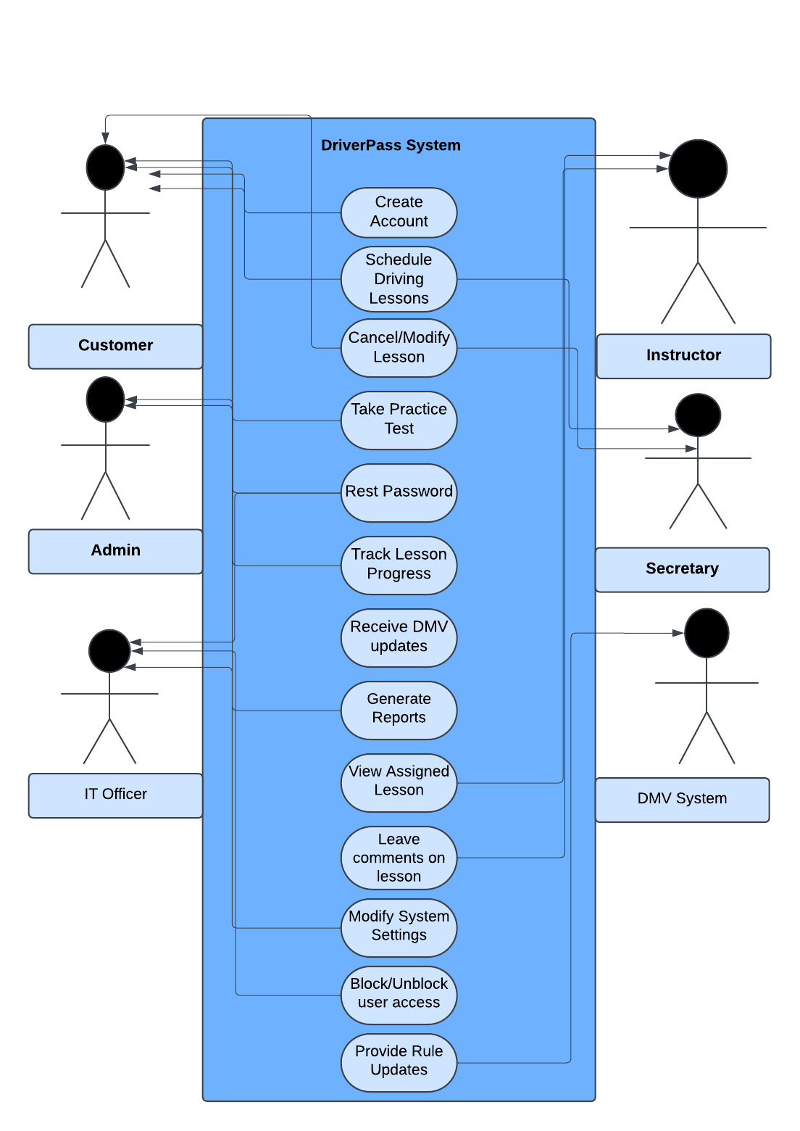

### UML Activity Diagrams

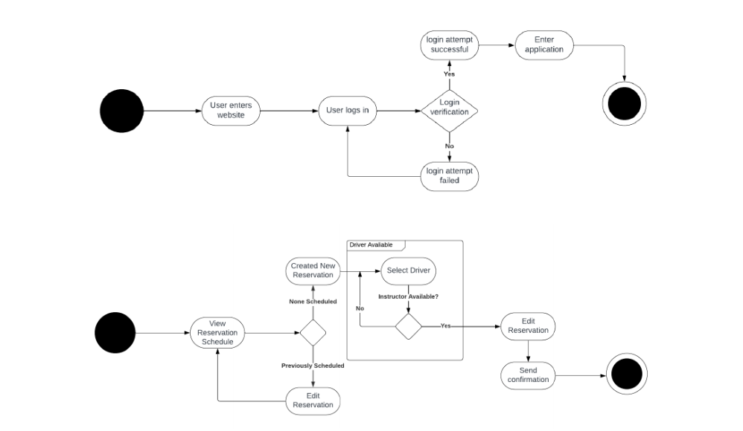

### UML Sequence Diagram

### UML Class Diagram

## Technical Requirements

***1. Hardware Requirements***

* ***Cloud-Based Server****: The system requires a reliable cloud server to host the web application and database, ensuring scalability and accessibility.*
* ***User Devices****:*
  + *Desktop computers, laptops, tablets, or smartphones with internet browsers to access the system.*
  + *Dedicated machines for administrators and IT officers for managing the system.*
* ***Storage****: Adequate cloud storage to securely store user data, lesson schedules, test results, and DMV updates.*
* ***Backup System****: Hardware to ensure automated, redundant backups to prevent data loss.*

***2. Software Requirements***

* ***Operating System****:*
  + *Windows Server or Linux (for server hosting).*
  + *Any modern operating system (Windows, macOS, iOS, Android) for end-user devices.*
* ***Web Server****:*
  + *Apache HTTP Server or NGINX to host the web application.*
* ***Database****:*
  + *SQL Server or MySQL to manage data for customers, lessons, packages, and instructors.*
* ***Development Frameworks****:*
  + *Frontend: React or Angular for building the web interface.*
  + *Backend: Java or Python for business logic and integrations with DMV updates.*
* ***Security Software****:*
  + *SSL/TLS certificates for secure communication.*
  + *Antivirus and anti-malware software for the server environment.*

***3. Tools***

* ***CASE Tool****: Lucidchart (or equivalent) to create and manage UML diagrams.*
* ***Development Tools****:*
  + *IDEs like Visual Studio Code, IntelliJ IDEA, or PyCharm for coding.*
  + *Version control systems like Git/GitHub for collaboration and version tracking.*
* ***Monitoring Tools****:*
  + *Tools like Splunk or Prometheus for system health monitoring.*
* ***Reporting Tools****:*
  + *Excel or Google Sheets for generating offline reports based on system data.*

***4. Infrastructure***

* ***Cloud Hosting Platform****:*
  + *AWS, Microsoft Azure, or Google Cloud Platform for hosting and infrastructure management.*
* ***Network****:*
  + *High-speed internet connection to ensure low latency for users accessing the system.*
  + *VPN for secure administrative access to sensitive parts of the system.*
* ***Integration****:*
  + *API connection with the DMV system for real-time updates on driving rules and test requirements.*